Chartitmd User Manual

# About Chartitmd

Chartitmd is a software application that allows the user to input and store data for their patients. The application allows the use of creating and modifying data. Login information is used so when certain data is created, the data displays which user has created the data and which data has been modified.

# Table of contents

User Login – 4

Patient Search – 5

Patient header bar – 6

Patient Medication – 7

Patient Summary – 8

Patient Contact – 9

# User Login

The user login page is where you will log into your student account and is necessary to participate in assignments.

Enter your username and password in the corresponding boxes and click on the login button to log into the application.

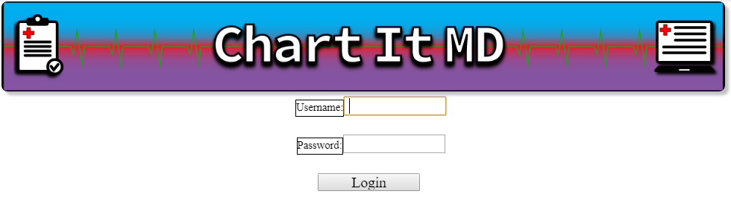

Login page

Having trouble logging in? Contact your instructor.

# Patient Search

After logging in, you will be brought to this page afterwards. The patient search page is used to search for patients by using their date of birth. To search for a patient, type the date by this format: YY-MM-DD with the dashes included. Once you have found the patient your looking for, click on the patient’s ID to the left of the name.

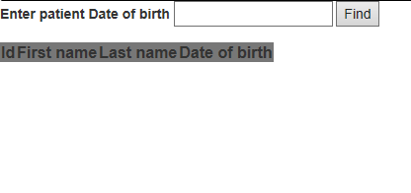

Page without an input

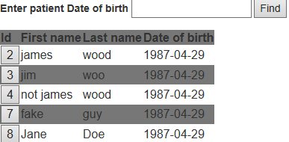

Page after inputting a date

# Patient header bar

The patient header bar is at the top of the page, and is what displays the patients information. It will be available on all of the pages other than the user login page.

The arrow in the top left corner of the bar will hide/show a majority of the content of the bar.

Clicking on the arrows on certain data fields will hide/show options to create a new entry for the field and showing more data from the corresponding field

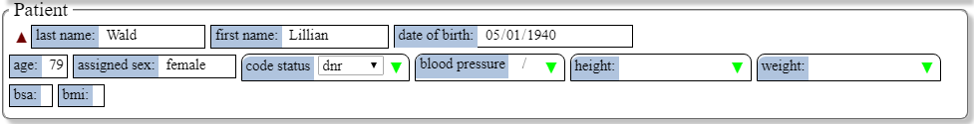Navbar opened



Navbar closed

# Patient Medication

The patient medication page is where you will find the patient’s current medication they are taking, adding medication, and administering.

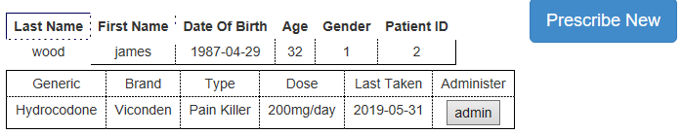

Patient Medication page

Clicking on the prescribe new button will bring up a menu, allowing you to input the type of medication and what medication and the dosage of the medication. When you are done, click Save changes to save your input. To cancel your input click Close.

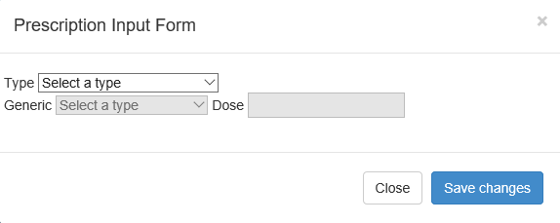

Menu for adding new prescription

# Patient Summary

The patient summary page is where information like the patient’s allergies, current problems, medication, surgical history, activity, and orders.

To save new information, click on the save button located about the allergies text box.

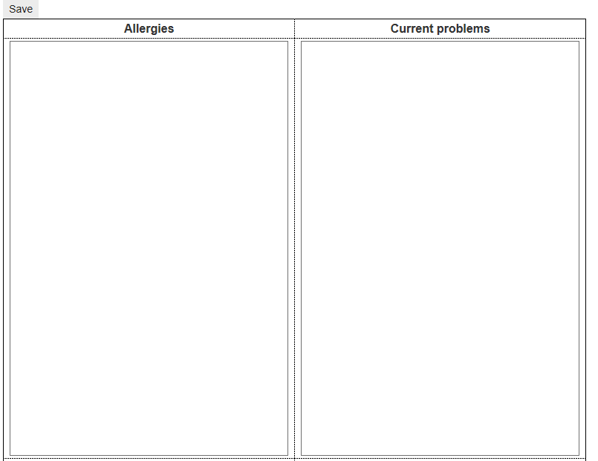

Save button, Allergies and current problems text boxes, Medication and surgical history are below the row shown above and the activity and orders text boxes are below the medication and surgical history text boxes.

# Patient Contact

The patient contact page is where the patient’s contact information such as their address, email, and phone number is inputted and saved.

The Email, addresses, and phone number are editable when in edit mode and the first and last name cannot be edited.

Clicking the save button will save the edits you made to the input fields and the cancel button cancels the edit without saving your changes

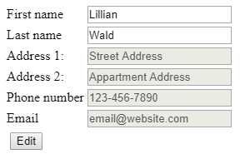 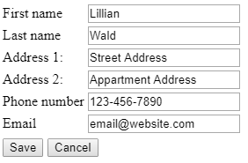  
 Page by default Page in edit mode